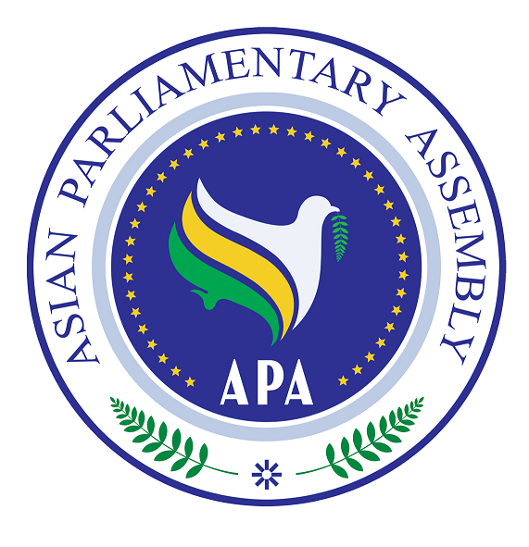
Asian Parliamentary Assembly (APA)
REGISTRATION FORM
APA Coordinating Meeting alongside the 151st IPU Assembly
Venue: CICG, Plenaries E&F
Sunday, October 19, 2025

Please fill in one registration form for each participant in (block letters) and return it to the APA Secretariat at the following e-mail address latest by 14 October
- Delegation of: …………

- Title: Please check Mr. Ms. Dr. other
- First Name:
- Last Name:

- Position in the parliament
……………………………………………………………………………………

- Phone No. | - …………………..……………………………………………..  - Country Code City Code Number
- Cell phone  - Fax No. | - …………………………………………………………………  - ………………………………………………………………..
- Email Address: | - ……………….……………………………………………..

Any Proposal on Emergency Item:

